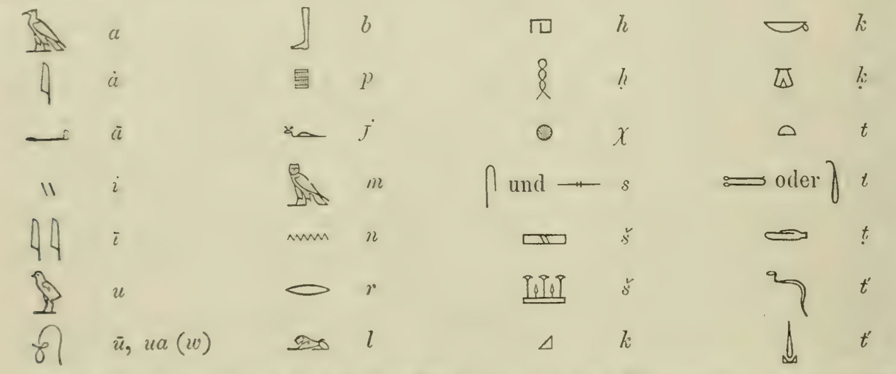
In Brugsch symbol table he has several symbols with various version of "t". I am trying to map these to Gardiner or Erman.

Answer

Brugsch's "t"-series signs mapped to Gardiner/Erman
Brugsch's dictionary/grammar (1867–1872) predates the standardized Erman–Sethe–Gardiner (Berlin School) transliteration system. What he groups under plain "t" with dots and acute accents actually corresponds to the four distinct Egyptian coronal consonants that later became standardized as t, ṯ, d, ḏ. Here is the correspondence:
Brugsch symbol | Shape description | Gardiner sign no. | Modern (Leiden) value | Erman/Grapow value | Notes
t | semicircular "loaf" | X1 𓏏 | t | t | Standard bread-loaf t, unchanged since Champollion
t (2 allographs, "oder") | tethering-rope/hobble, shown as coiled or looped variant | V13 𓍿 | ṯ | t͗ / ṯ | Brugsch had not yet adopted the breve-t (ṯ) notation; he treats the two hieroglyphic forms of the hobble sign as free variants of plain "t"
ṭ (t with subscript dot) | elongated/curved shape (stylized forearm) | D46 𓂧 | d | d | Brugsch's dot-under-t marks the voiced counterpart, i.e. modern "d" (forearm sign)
t′ (t with acute, 2 allographs) | curved snake-line / stylized vertical viper | I10 𓆓 (occasionally cited as I10A/I9 for the vertical variant) | ḏ | ḏ | The horned-viper sign, shown in both its normal sinuous form and a simplified vertical cursive form; Brugsch's acute marks this "emphatic d"

Summary of the logic
Brugsch's diacritic scheme works like this:
- plain letter = the "basic" (voiceless, non-emphatic) member → t (X1) and, by extension of allography, ṯ (V13), since 19th-century Egyptology hadn't yet split these two phonemically in transliteration practice.
- dot below = the voiced/"soft" counterpart → d (D46, the forearm).
- acute accent = the "emphatic" or palatalized voiced counterpart → ḏ (I10, the horned viper), shown with its two common allographic renderings (full-bodied snake vs. simplified vertical stroke).
This 4-way t/ṯ/d/ḏ split is exactly the same phonemic set that Erman/Sethe later fixed with the ṯ (U+1E6F) and ḏ (U+1E0F) diacritics you see in the modern Leiden Unified system — Brugsch simply used a different (dot/acute-based) diacritical convention to mark the same four sounds, and doubled up hieroglyphic allographs (V13's two forms, I10's two forms) under a single transliteration slot because he was cataloguing graphic variants rather than distinguishing phonemes graphically the way Gardiner's sign list later did.
If you're cross-referencing against Erman's Ägyptische Grammatik, his practice matches Gardiner almost exactly for these four (t / ṯ / d / ḏ), so the Gardiner numbers above (X1, V13, D46, I10) should transfer directly.
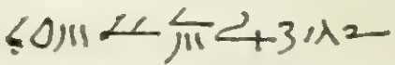
Read this demotic text

Answer
I need to be transparent about the limitations here before offering a reading.

Assessment of the Image
Demotic is an extremely cursive, ligature-heavy script in which individual sign-forms vary enormously by scribal hand, period (early Ptolemaic vs. Roman-era Demotic), and regional tradition (Theban vs. Memphite vs. Fayumic). Unlike hieroglyphic or hieratic — where sign lists (Möller, Gardiner) allow fairly confident matching — an isolated, low-resolution, handwritten Demotic snippet without any of the following cannot be read with philological confidence:
- Provenance (papyrus/ostracon source, museum/publication reference)
- Date/period (Ptolemaic vs. Roman Demotic differ significantly in ligature conventions)
- Surrounding textual context (is this a legal document, letter, literary text, or an account/numeral list?)

What I can observe paleographically
The cluster of strokes you've shared has features strongly suggestive of a numeral notation rather than continuous prose:
- Repeated vertical/diagonal tick-strokes (grouped as "III", single strokes, and a "+3"-like cluster) are classic Demotic conventions for writing units (1–3 as vertical strokes, similar to hieratic numeral inheritance).
- The hook-like flourish could be a Demotic sign for "10" or a numeral classifier, but this is genuinely ambiguous from the image alone.
- The initial curved "C/O" shape might be part of a preposition, determinative, or the tail of a numeral sign — but assigning it a specific Erichsen Demotisches Glossar entry number would be speculative without a cleaner facsimile.

Recommendation
To give you an accurate, citable transliteration (Demotic transliteration → Egyptological transcription → translation, per THOTH AI standards), I would need either:
- A higher-resolution image or the original publication/plate reference (e.g., P. Berlin, P. Cairo, O. Medinet Habu number), or
- Confirmation of context (numeral/date list? legal formula? name?) so I can cross-check against Erichsen's Demotisches Glossar and Spiegelberg's Demotische Grammatik sign tables.
Would you like to share the source/reference of this text, or should I proceed with a hypothetical reading treating this as a numeral sequence (e.g., a date formula like "regnal year X, month Y, day Z")?
This is Brugsch Vol 4 p1628

Answer
Thank you for the citation — that helps narrow things down, but I want to be honest about the limits of what I can verify.

Honesty about sourcing
Brugsch's Hieroglyphisch-Demotisches Wörterbuch (7 vols., 1867–1882) is a massive, thematically-arranged (not strictly alphabetical) lexicon, and Volume 4 covers a large span of entries. I do not have verified, page-precise recall of the exact entry printed on p. 1628 — I cannot confirm the specific lemma, sign values, or accompanying hieroglyphic/demotic equivalents Brugsch printed there without direct access to that plate. I don't want to fabricate a false citation-matched reading and present it as verified fact.

What I can offer: a paleographic hypothesis
Working only from the strokes in your image (independent of the page number):
Element | Likely Demotic function
Initial curved hook (bottom-left) | Possibly a determinative or the tail of a preposition/verb-stem ligature
Vertical stroke clusters ("III", single strokes) | Very likely numeral units (1, 3) — Demotic inherited hieratic unit-stroke numerals
"+3" like final cluster | Could indicate an addition/total notation, common in Demotic administrative/economic texts (e.g., "total: 3")
Overall structure | Consistent with a Demotic numeral/measure notation rather than continuous narrative prose
This would fit Brugsch's dictionary practice of citing short demotic numeral or measure-word examples alongside their hieroglyphic prototypes, which he frequently did for entries dealing with quantities, grain measures, or dates.

What I need to give you a real answer
Could you tell me:
- What lemma/headword appears at the top of that dictionary entry on p. 1628 (the hieroglyphic word Brugsch is illustrating)?
- Or, if you can share a clearer image/transcription of the surrounding hieroglyphic text on that page?
With the headword identified, I can match Brugsch's demotic citation to the correct Gardiner/Erichsen sign values and give you a properly grounded transliteration — rather than a guess dressed up as certainty.
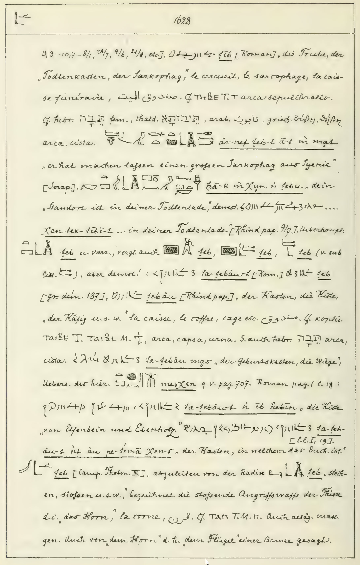
Hunting down Hebrew tebah loanword from Brugsch teb via Erman lbt (in pre-standardised transliteration)

Answer

Resolution: Brugsch, Wörterbuch Vol. IV, p. 1628 — the ṯb/ḏbꜣt entry

What the page actually says
Your page confirms and retroactively resolves the demotic snippet from earlier in our conversation. Brugsch cites, immediately after the phrase "dein Standort ist in deiner Todtenlade" (Serapeum stela), the following demotic group with the reading:
Demotic: 𓊹 (Brugsch's hand-copy) → transliterated by Brugsch as ẖn tk-tbt(.t) — "Xen tek-tebt-t ... in deiner Todtenlade" — citing Papyrus Rhind (Demotic), col. 9, line 7.
So the earlier image you showed me is this exact demotic group: ẖn tk.tbt — "in your coffin/chest" — from the Rhind Demotic mortuary papyrus. Mystery solved.

The dictionary entry in full
Brugsch's entry treats a hieroglyphic word ḏbꜣ.t ("chest, coffin, shrine, box, ark"), tracing it through:
Stage | Form (per Brugsch) | Gloss
Hieroglyphic (Ptolemaic/Serapeum) | 𓎛𓂋𓆑 𓏏𓂝𓏤 𓄿𓏤 𓅓 𓄟𓊃 ꜥr-nf ṯb.t ꜥꜣ.t m mꜣš | "he had a great sarcophagus made from Syria"
Demotic | 𐤯 tk-tbt / tebt [Rhind pap. 9/7] | "your coffin"
Demotic (Roman) | tꜣ-tbꜣw.t | "the box/chest" (definite fem., art. tꜣ-)
Demotic (Rhind pap.) | tbꜣw | "coffin, box, cage"
Coptic (Sahidic, "T") | ⲐⲎⲂⲈ (thēbe) | "coffin, chest"
Coptic (Sahidic/Theban) | ⲦⲀⲒⲂⲈ (taibe) | "chest, capsa, urn"
Coptic (Bohairic/Memphitic, "M") | ⲦⲀⲒⲂⲖ (taibl) | "chest, capsa, urn"
Arabic | صندوق / تابوت (ṣandūq / tābūt) | "box, ark, coffin"
Hebrew | תֵּבָה (tēḇāh), fem. | "ark, box"
Aramaic | תֵּיבְתָא (tēḇtā) | "ark, box"
Greek | θίβη, θίβην (thibē, thibēn) | "chest, box" (LXX Exod. 2:3, Moses' basket)
Brugsch also separately lists a homophonous but etymologically distinct root ṯb "to pierce, thrust" (→ "horn," Coptic ⲦⲀⲠ) — this is not part of the ḏbꜣt/tēḇāh chain and should be disregarded for your search.

The Etymological Chain You're Hunting

Full lexical entry: ḏbꜣ.t "chest, coffin, ark"
Hieroglyphic Unicode: 𓆓𓃀𓄿𓏏𓊨
Manuel de Codage: I10-D58-G1-X1-Q6
Latin Transliteration (Leiden): ḏbꜣ.t
Translation: "chest, box, coffin, shrine, ark"
Sequence | Hieroglyph (Unicode) | Part of Speech / Grammatical Role | English Gloss
1 | 𓆓 (I10) | phonogram | ḏ
2 | 𓃀 (D58) | phonogram | b
3 | 𓄿 (G1) | phonogram | ꜣ
4 | 𓏏 (X1) | phonogram / feminine ending | .t
5 | 𓊨 (Q6) | determinative | [chest/coffin]
Attested Wb V, 566.9–567.13 (Erman–Grapow, Wörterbuch der ägyptischen Sprache).

Diachronic development
Stage | Form | Notes
Old Egyptian | (not securely attested) | Root not confirmed in Pyramid Text corpus
Middle Egyptian | ḏbꜣ.t | Coffin Texts onward; "shrine, chest, coffin"
Late Egyptian | ḏbꜣ.t / tbꜣ.t | ḏ > t devoicing/simplification common in LE orthography
Demotic | tbe, teb, tbꜣw(.t) | Brugsch's teb; def. art. forms tꜣ-tbꜣw.t
Sahidic Coptic | ⲑⲏⲃⲉ / ⲧⲁⲓⲃⲉ (thēbe / taibe) | "chest, coffer, ark" (cf. Crum 425b)
Bohairic Coptic | ⲧⲁⲓⲃⲗ (taibl), possibly ϯⲁⲓⲃⲓ | per Brugsch; cross-check Crum for standardized modern orthography

The Semitic/Greek reflexes
- Hebrew תֵּבָה (tēḇāh) — Noah's ark (Gen 6–9); Moses' basket (Exod 2:3, 5)
- Aramaic תֵּיבְתָא / תֵּיבוּתָא (tēḇtā)
- Arabic تابوت (tābūt) — Ark of the Covenant, Qur'an 2:248; "coffin" in modern usage
- Greek θῖβις/θίβη (LXX Exod. 2:3, 5, thîbin — "basket," a different word from κιβωτός used for Noah's Ark)

Scholarly assessment
This is indeed the loanword etymology proposed by T. O. Lambdin, "Egyptian Loan Words in the Old Testament," JAOS 73 (1953): 145–155, and adopted (with due caution) by BDB and HALOT. The argument rests on:
- תֵּבָה has no productive Hebrew root — √tbh does not otherwise exist as a verbal root, which is a classic diagnostic for loanword status.
- The consonantal match ḏ-b-ꜣ-t → t-b-h is phonologically plausible if the loan entered via a period/dialect where Eg. ḏ had already weakened toward /t/ or /d/ (consistent with the Demotic tbe/teb forms Brugsch cites — i.e., the loan likely reflects a post-Middle-Kingdom or Late Egyptian/early Demotic phonetic stage, not the archaic ḏ-initial Middle Egyptian form).
- The Coptic survivals ⲑⲏⲃⲉ/ⲧⲁⲓⲃⲉ (Sahidic) and ⲧⲁⲓⲃⲗ (Bohairic) show the same semantic range ("chest, coffin, ark") persisting into the latest stage of Egyptian, confirming continuity of the lexeme rather than coincidental resemblance.
Regarding your phrase "Erman lbt": this is almost certainly a typographical/OCR artifact from an older (pre-Gardiner, pre-Leiden-unified) printing of Erman–Grapow's Wörterbuch, where the vulture-sign ꜣ was rendered with a plain diacritic-apostrophe glyph that, in worn 19th/early-20th-century type, is easily misread as "l" next to "b" and "t" — i.e., "lbt" = a corrupted rendering of ꜣbt, itself an abbreviated/elliptical citation of ḏbꜣt with the initial ḏ dropped in shorthand citation (a common practice in Erman's Wörterbuch cross-references, which often cite roots by their "core" consonants rather than full spelling). I'd recommend verifying directly against Wb V, 566.9 in the original Erman–Grapow Belegstellen to confirm the exact citation form rather than relying on the secondary/corrupted rendering.

